
H1b Visa
USING HADOOP FRAMEWORK

BY: PIYUSH
student id: S180020200197
Mail id- sharmapiyush.0811@gmail.com

1.ABSTRACT
The project is focussed on analysis of h1b visa data. Using Hadoop, an open source framework for distributed computing, the raw data of the census is processed and analysed.

BIG DATA:
Due to the advent of new technologies, devices, and communication means like social networking sites, the amount of data produced by mankind is growing rapidly every year. Big Data it is a collection of large datasets that cannot be processed using traditional computing techniques. Some of the fields that come under the Big Data.
- Black Box Data
- Social Media Data
- Stock Exchange Data
- Transport Data
- Search Engine Data
Thus, Big Data includes 5Vs:
- Volume: refers to the vast amount of data generated every second.
- Velocity: refers to the speed at which new data is generated and the speed at which data moves around.
- Variety: refers to the different types of data we can now use.
- Veracity: refers to the messiness or trustworthiness of the data.
- Value: refers to our ability to turn our data into value.
The data in it will be of three types:
Structured data: Relational data.
Semi Structured data: XML data.
Unstructured data: Word, PDF, Text, Media Logs.
BIG DATA can be analysed for insights that lead to better decisions and strategic business moves.
2.1) IMPORTANCE OF BIG DATA:
The importance of BIG DATA doesn’t only mean how much data we have, but what we do with it. We can take data from any source and analyse it to find answers that enable
1) Cost reductions
2) Time reduction
3) new product development and optimized offerings
4) smart decision making.

When we combine BIG DATA with high-powered analytics, we can accomplish business-related tasks such as:

- Determining root causes of failures, issues and defects in near-real time.
- Generating coupons at the point of sale, based on the customer’s buying habits.
- Recalculating entire risk portfolios in minutes.
- Detecting fraudulent behaviour before it affects the organization.

HADOOP:
Hadoop is an Apache open source framework written in java that allows distributed processing of large datasets across clusters of computers using simple programming models. A Hadoop frame-worked application works in an environment that provides distributed storage and computation across clusters of computers. Hadoop is designed to scale up from single server to thousands of machines, each offering local computation and storage.

3.1 HISTORY OF HADOOP:
The genesis of Hadoop came from the Google File System paper that was published in October 2003. This paper spawned another research paper from Google – MapReduce: Simplified Data Processing on Large Clusters. In 2006, Doug Cutting Joined Yahoo and took with him the Nutch project as well as ideas based on Google’s early work with automating distributed data storage and processing. The Nutch project was divided – the web crawler portion remained as Nutch and the distributed computing and processing portion became Hadoop (named after Cutting’s son’s toy elephant). In 2008, Yahoo released Hadoop as an open-source project. Today, Hadoop’s framework and ecosystem of technologies are managed and maintained by the non-profit Apache Software Foundation (ASF), a global community of software developers and contributors.

3.2) MODULES IN HADOOP:
The project uses these modules:
- Hadoop Common: The java libraries and utilities that support the other Hadoop modules.
- Hadoop Distributed File System (HDFS): A distributed file system that provides high-throughput access to application data.
- Hadoop YARN: A framework for job scheduling and cluster resource management.
- Hadoop MapReduce: A YARN-based system for parallel processing of large data sets.
Other Hadoop ecosystem products at Apache which are used for the analysis:
Hive: A data warehouse infrastructure that provides data summarization and ad hoc querying.
Pig: A high-level data-flow language and execution framework for parallel computation.

HDFS (HADOOP DISTRIBUTED FILE SYSTEM):
Hadoop File System was developed using distributed file system design. It runs on commodity hardware. Unlike other distributed systems, HDFS is highly fault tolerant and designed using low-cost hardware.
HDFS holds very large amount of data and provides easier access. To store such huge data, the files are stored across multiple machines. These files are stored in redundant fashion to rescue the system from possible data losses in case of failure. HDFS also makes applications available to parallel processing.

4.1) Features of HDFS
- It is suitable for the distributed storage and processing.
- Hadoop provides a command interface to interact with HDFS.
- The built-in servers of namenode and datanode help users to easily check the status of cluster.
- Streaming access to file system data.
- HDFS provides file permissions and authentication.

4.2) HDFS ARCHITECTURE:
HDFS follows the master-slave architecture and it has the following elements.

Namenode(MASTER):
NameNode is at the heart of the HDFS file system which manages the metadata i.e. the data of the files is not stored on the NameNode but rather it has the directory tree of all the files present in the HDFS file system on a Hadoop cluster. NameNode uses two files for the namespace-
fsimage file- It keeps track of the latest checkpoint of the namespace.
edits file-It is a log of changes that have been made to the namespace since checkpoint.
Namenode can never be commodity hardware because the entire HDFS rely on it. It is the single point of failure in HDFS. Namenode must be a high-availability machine.
The system having the namenode acts as the master server and it does the following tasks:
- Manages the file system namespace.
- Regulates client’s access to files.
- It also executes file system operations such as renaming, closing, and opening files and directories.

Datanode(SLAVE):
It is the slave node which stores the actual data in blocks and retrieve them when they are told to by client or name node. They report back to name node periodically, with list of blocks that they are storing. These nodes manage the data storage of their system.
- Datanodes perform read-write operations on the file systems, as per client request.
- They also perform operations such as block creation, deletion, and replication as per the instructions of the namenode.

Block:
The minimum amount of data that can be read or written is generally referred to as a “block” in HDFS.
Generally, the user data is stored in the files of HDFS. The file in a file system will be divided into one or more segments and/or stored in individual data nodes. These file segments are called as blocks. In other words, the minimum amount of data that HDFS can read or write is called a Block. The default block size is 128MB, but it can be increased as per the need to change in HDFS configuration.
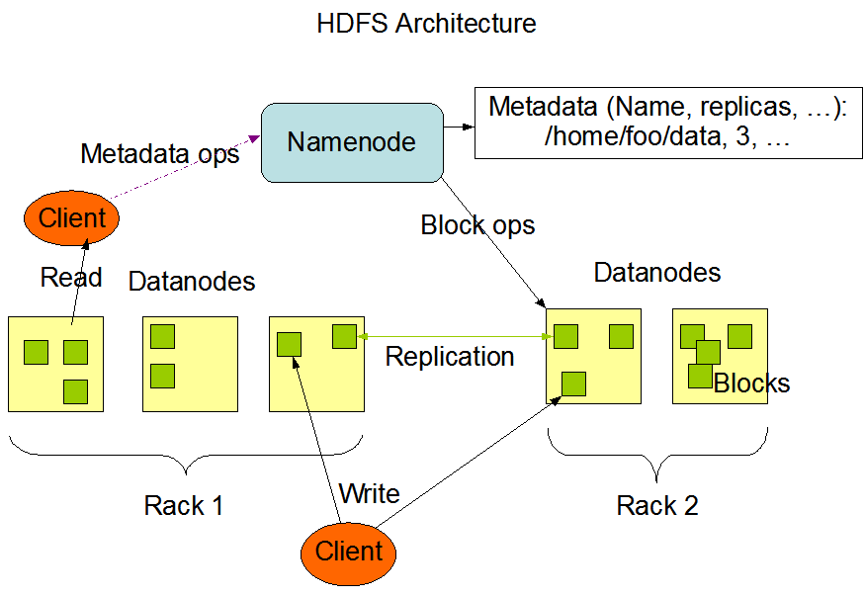

PROJECT IMPLEMENTATION:

5.1) Assumptions:
- Hadoop Cluster is Running
- Ecosystem Products (Pig, Hive) are installed
- H1b visa data is available in csv format

5.2) Prerequisites:
The H1b visa data is available in Hadoop file system.
- HIVE:
Apache Hive is a data warehouse infrastructure built on top of Hadoop for providing data summarization, query, and analysis. Hive gives an SQL-like interface to query data stored in various databases and file systems that integrate with Hadoop.

6.1) TASK 1:

Task 5.a: Find the most popular top 10 job positions for H1B visa applications for each year?

a) for all the applications
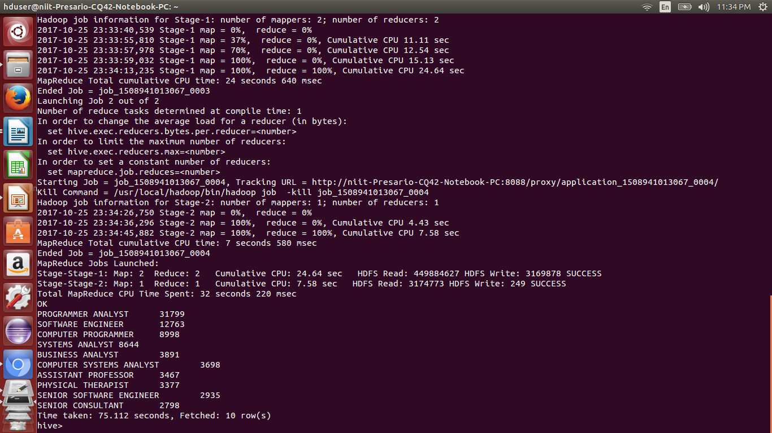
1: YEAR 2011

2. YEAR 2012
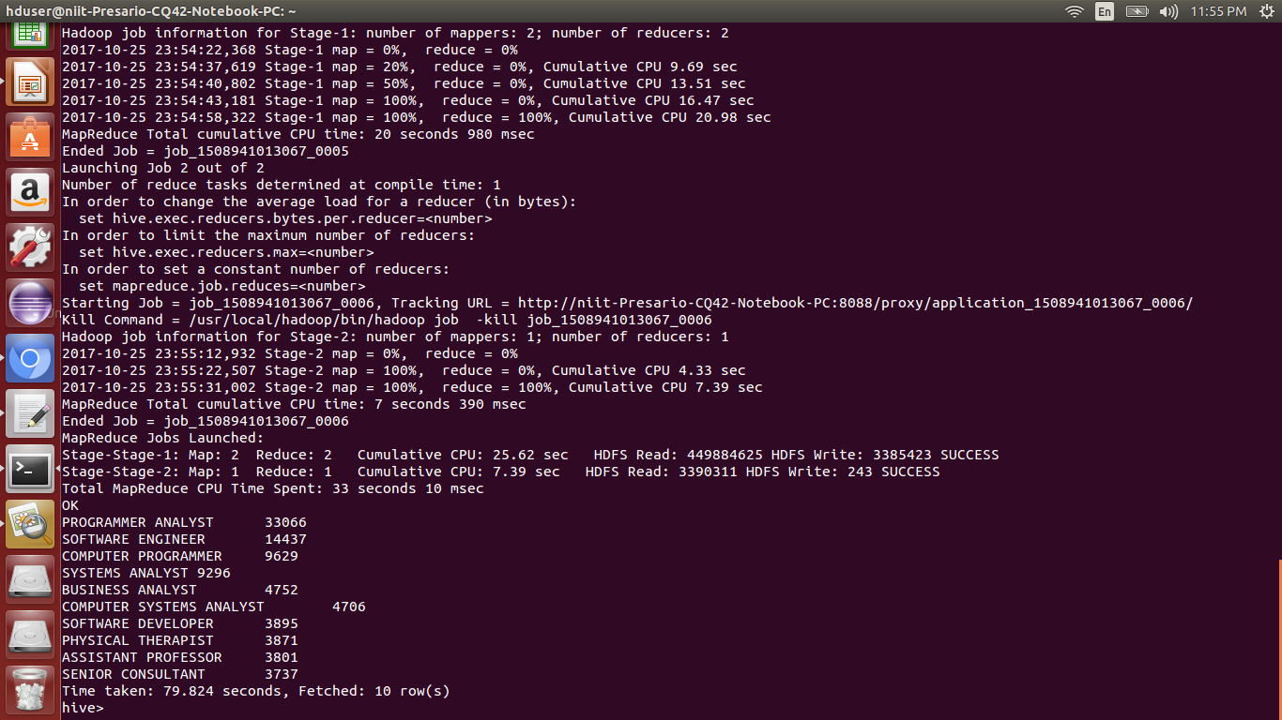

3. YEAR 2013
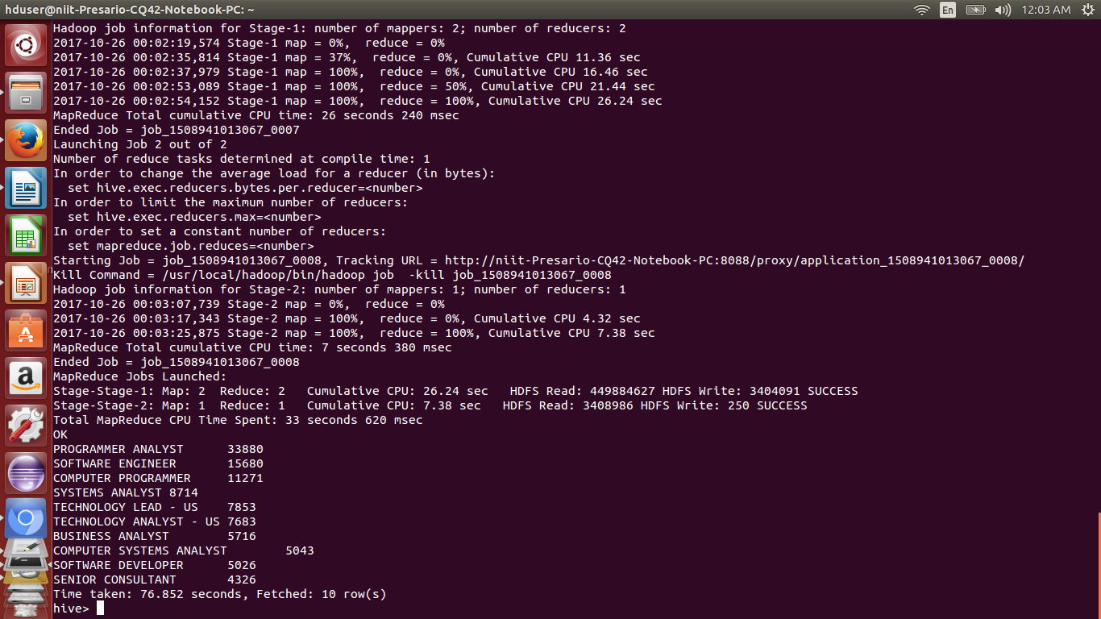
4.YEAR 2014
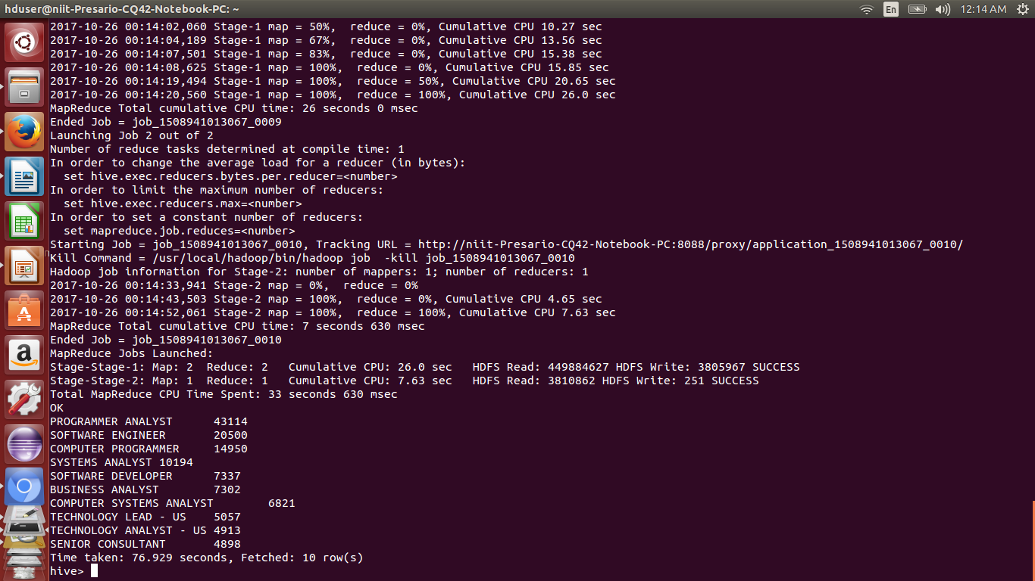

5.YEAR 2015
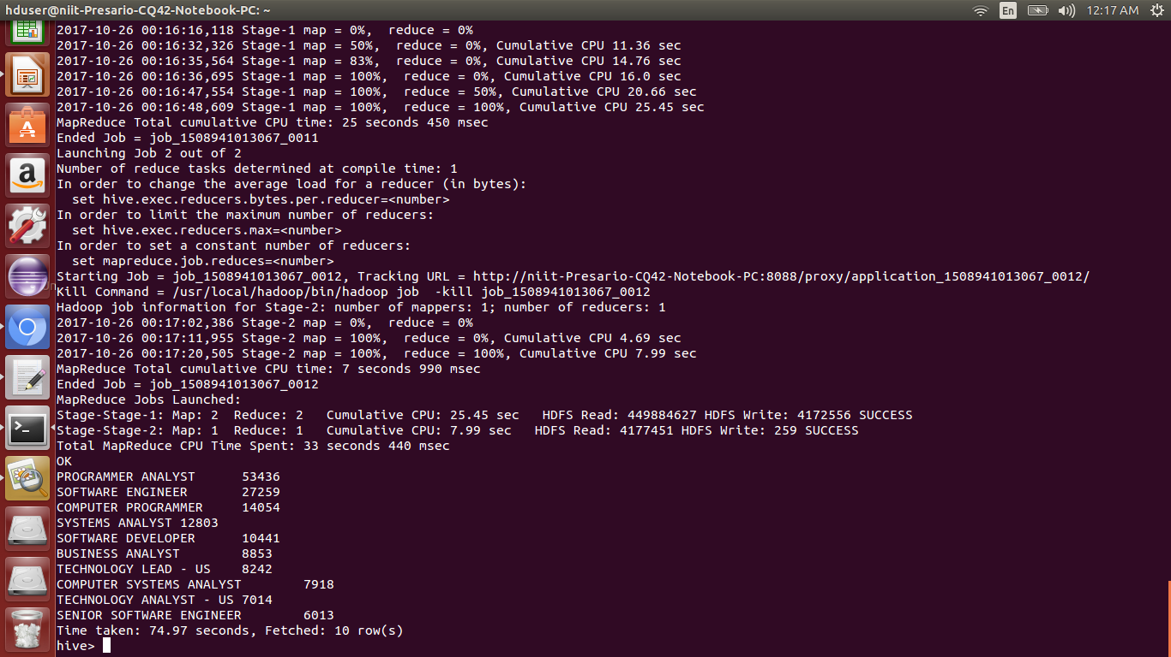

6.YEAR 2016
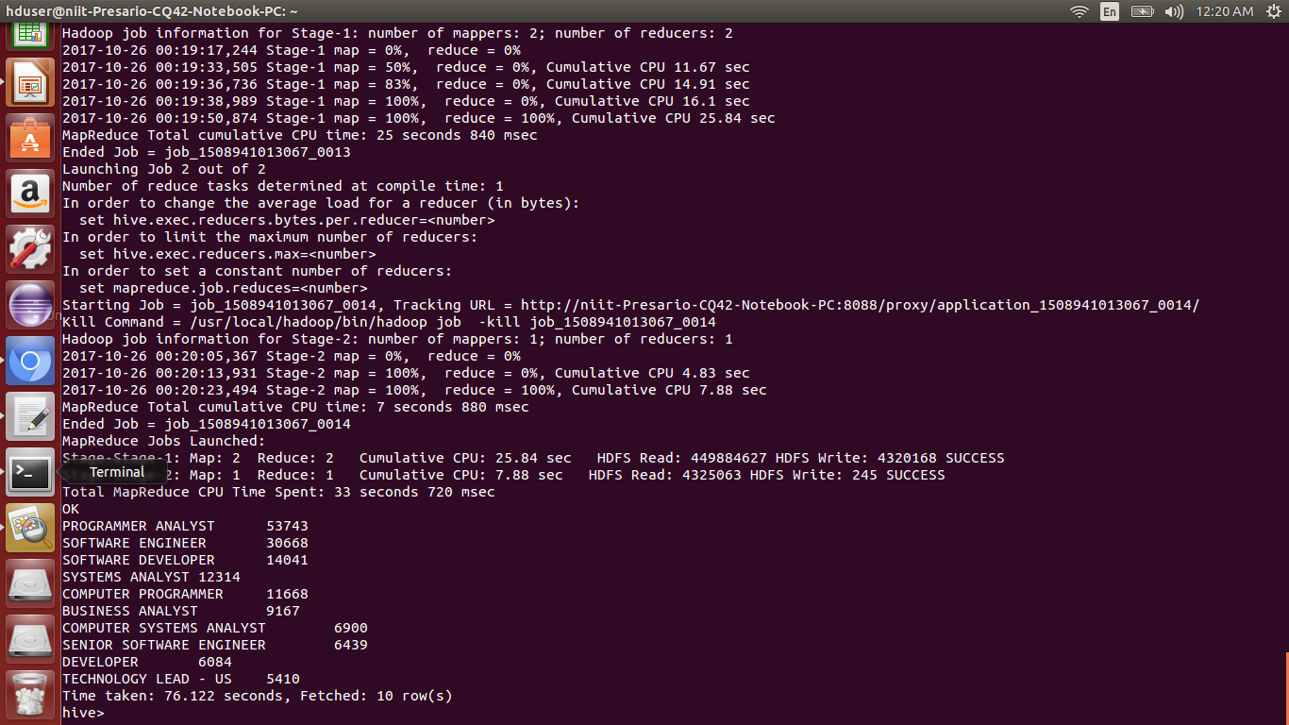

B:> FOR ONLY CERTIFIED CANDIDATES:
1.YEAR 2011
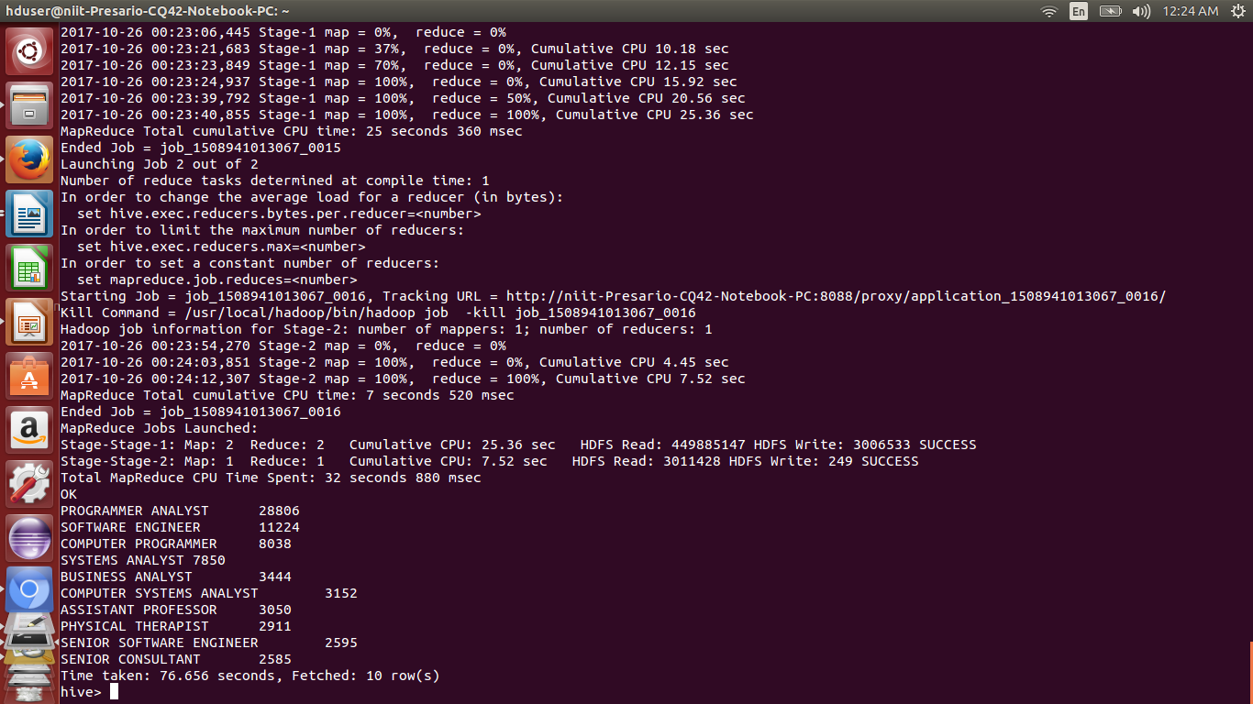

2.YEAR 2012

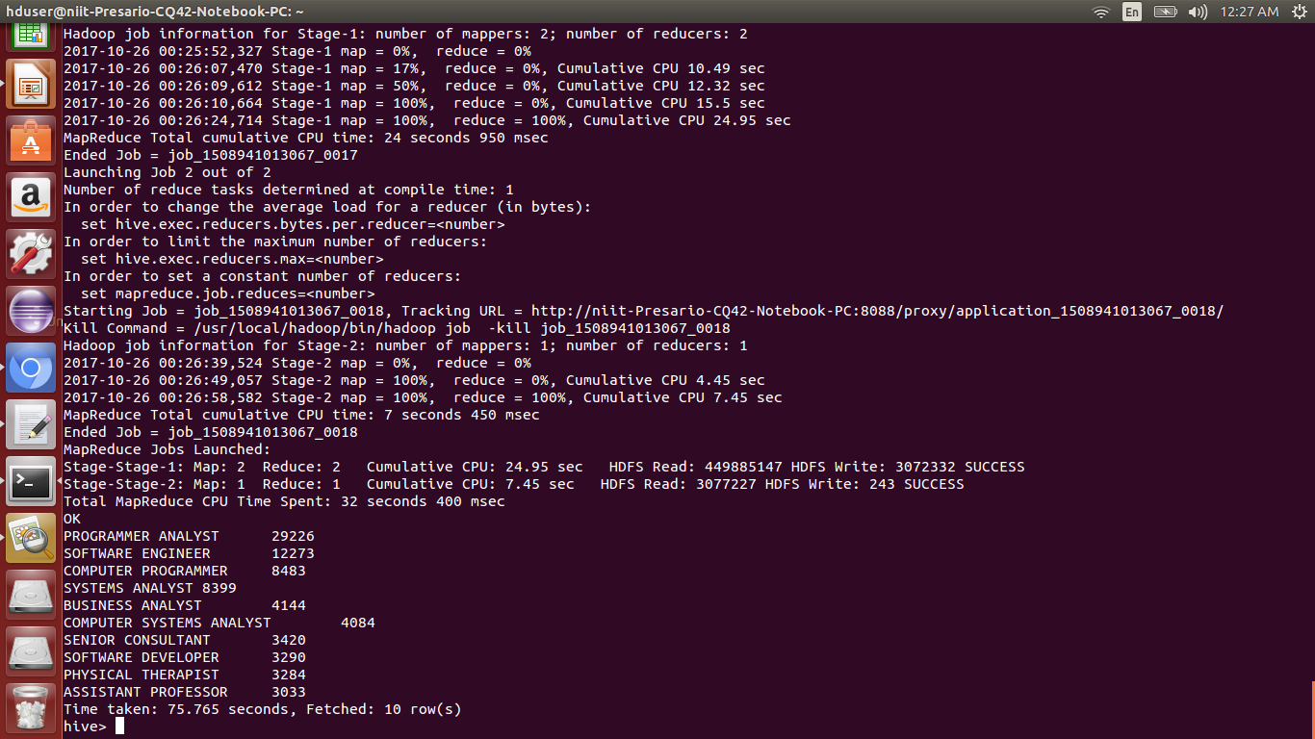

3.YEAR 2013

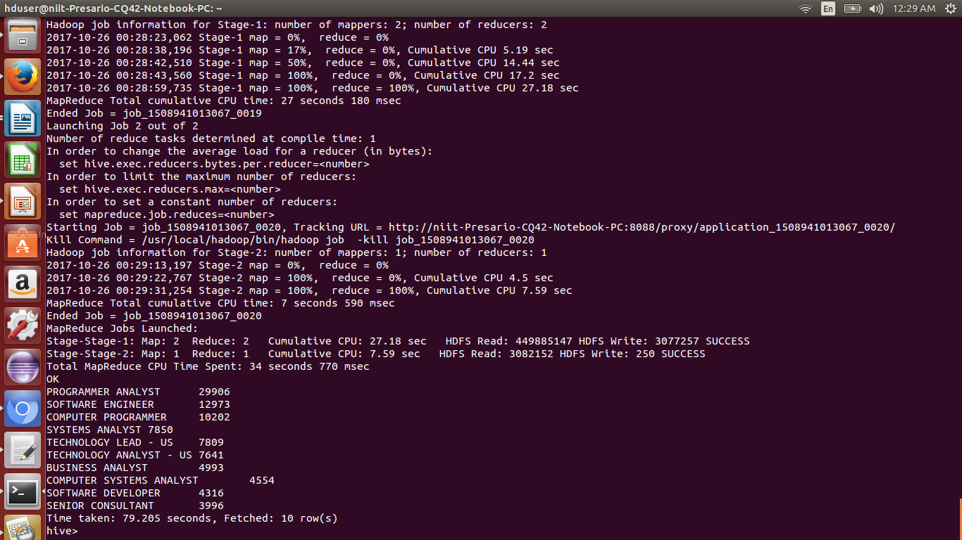

4.YEAR 2014

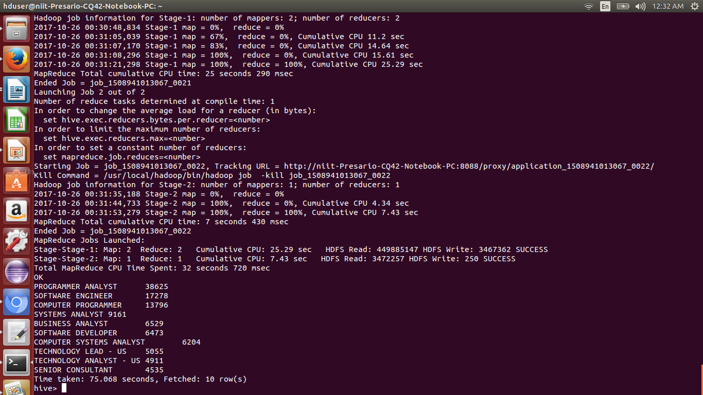

5.YEAR 2015
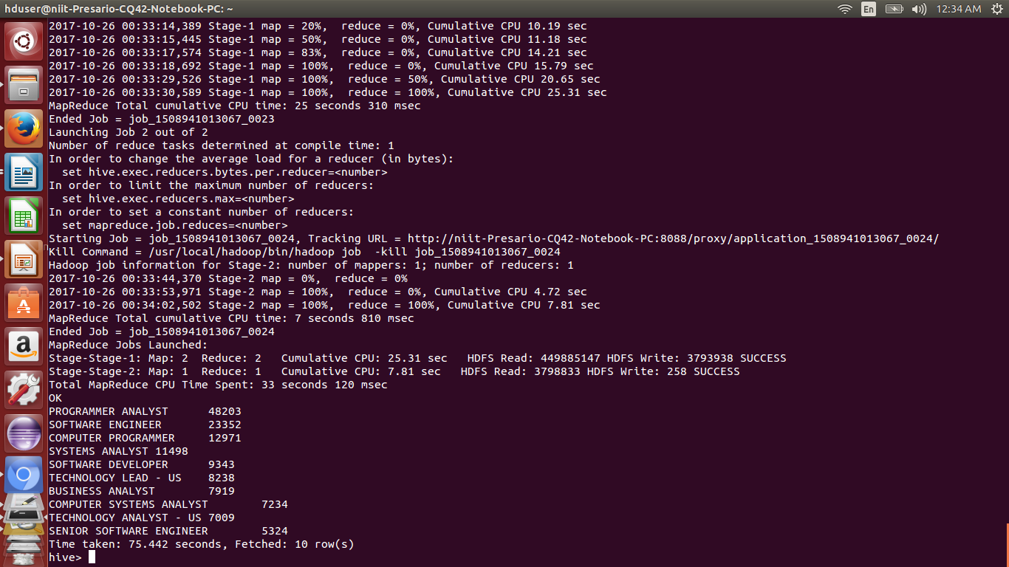

6.YEAR 2016

TASK 7) Create a bar graph to depict the number of applications for each year

select year, count(*) from h1b_final group by year;
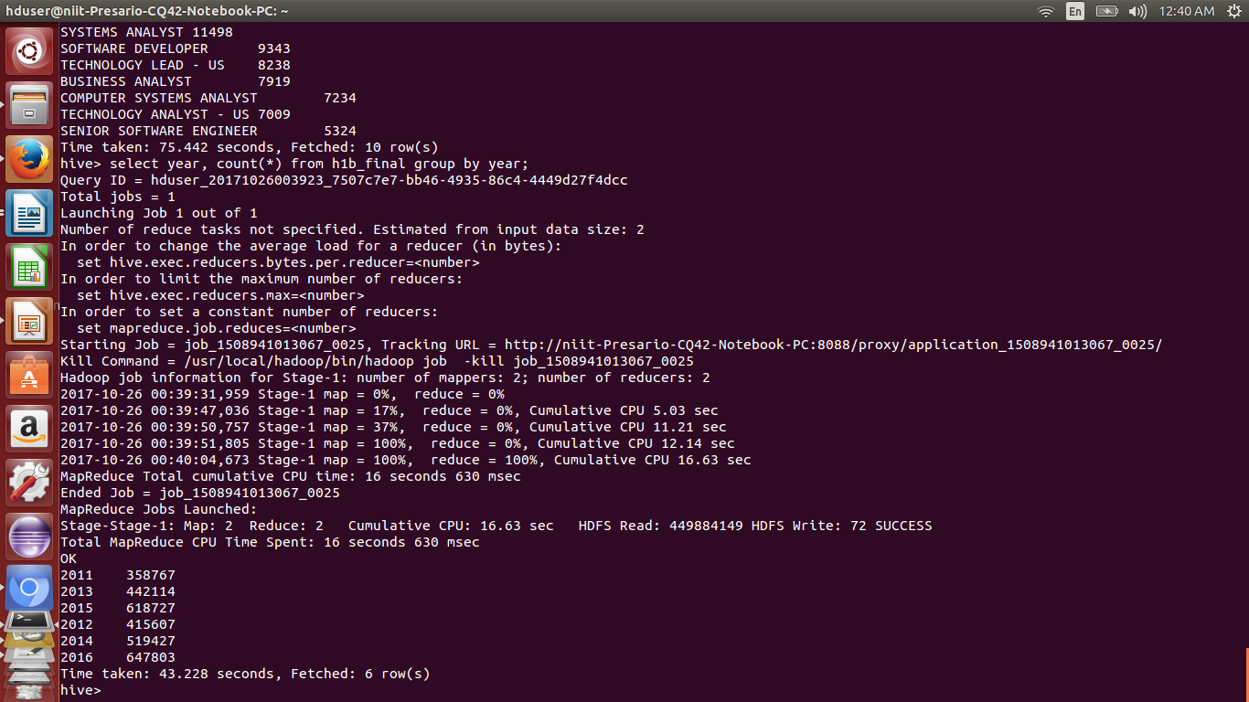
TASK 2B):
find top 5 locations in the US who have got certified visa for each year.[certified]
YEAR 2011
INSERT OVERWRITE LOCAL DIRECTORY '/home/hduser/Project/Hive/Question 2b/2011' row format delimited fields terminated by ',' select worksite,count(case_status) as temp,year from h1b_final where year ='2011' and case_status='CERTIFIED' group by worksite,year order by temp desc limit 5;
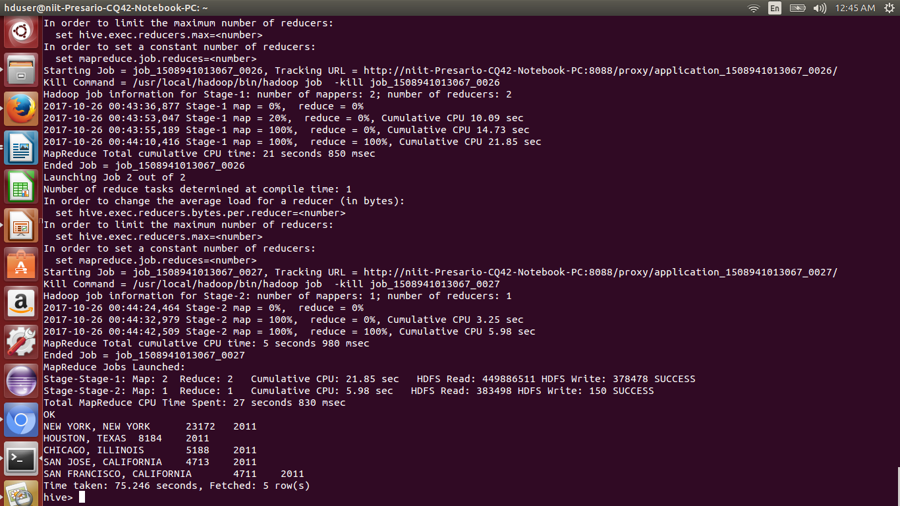
YEAR 2012
INSERT OVERWRITE LOCAL DIRECTORY '/home/hduser/Project/Hive/Question 2b/2012' row format delimited fields terminated by '/t' select worksite,count(case_status) as temp,year from h1b_final where year ='2012' and case_status='CERTIFIED' group by worksite,year order by temp desc limit 5;
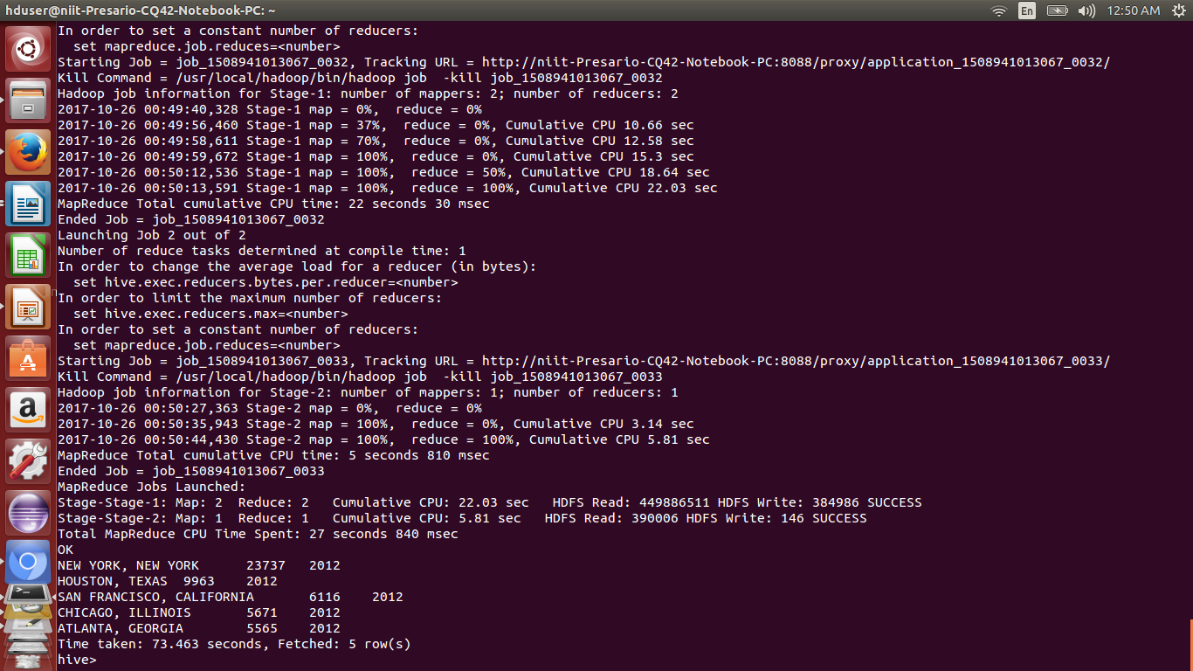
YEAR 2013

INSERT OVERWRITE LOCAL DIRECTORY '/home/hduser/Project/Hive/Question 2b/2013' row format delimited fields terminated by ',' select worksite,count(case_status) as temp,year from h1b_final where year ='2013' and case_status='CERTIFIED' group by worksite,year order by temp desc limit 5;
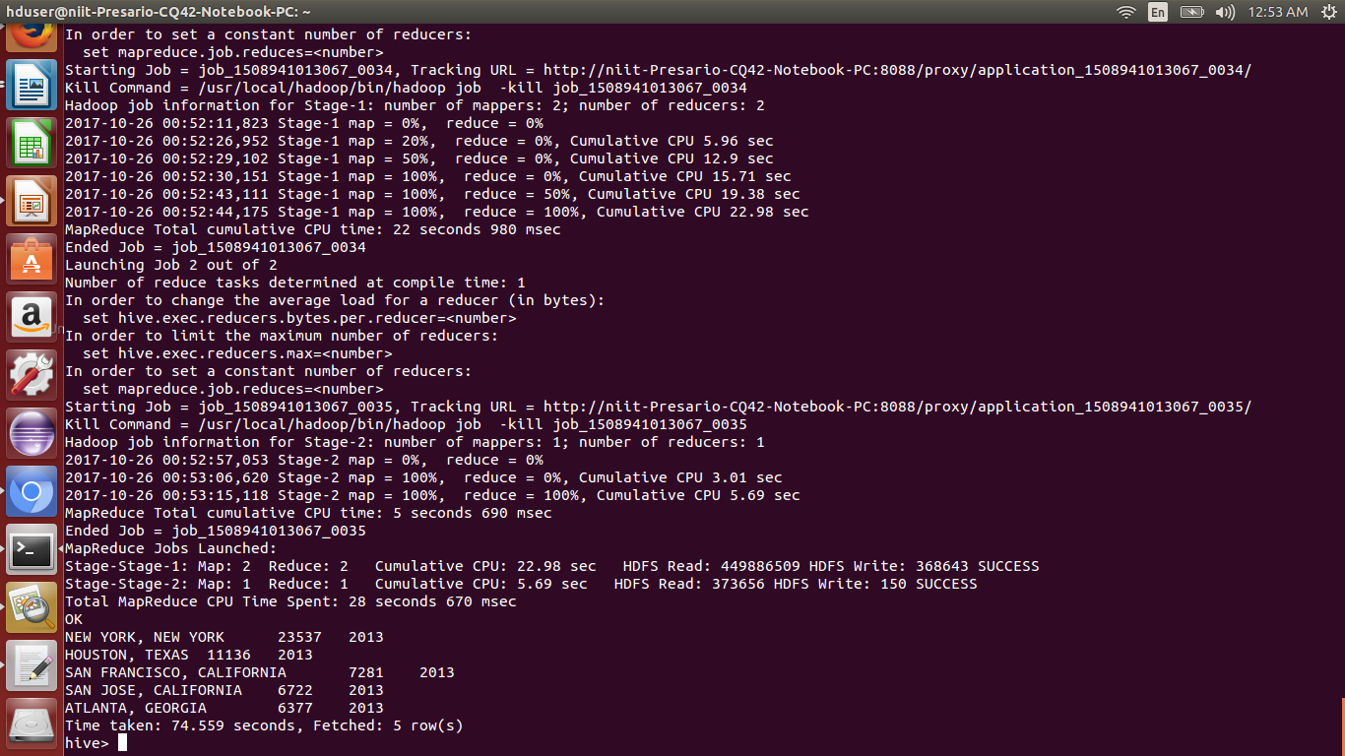

YEAR 2014
INSERT OVERWRITE LOCAL DIRECTORY '/home/hduser/Project/Hive/Question 2b/2014' row format delimited fields terminated by ',' select worksite,count(case_status) as temp,year from h1b_final where year ='2014' and case_status='CERTIFIED' group by worksite,year order by temp desc limit 5;
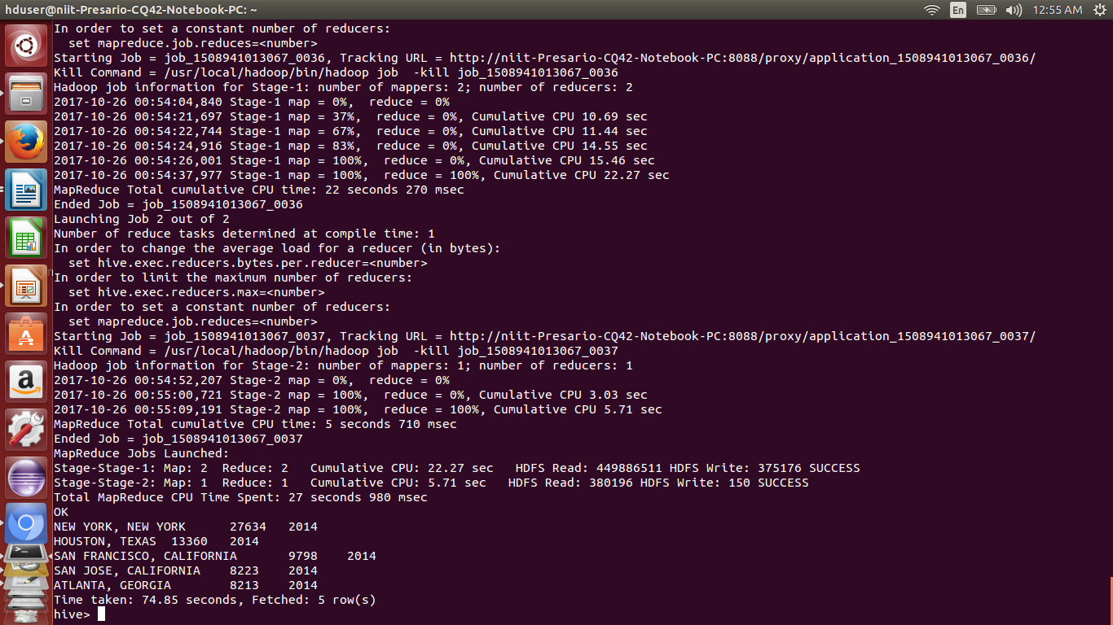

YEAR 2015

INSERT OVERWRITE LOCAL DIRECTORY '/home/hduser/Project/Hive/Question 2b/2015' row format delimited fields terminated by ',' select worksite,count(case_status) as temp,year from h1b_final where year ='2015' and case_status='CERTIFIED' group by worksite,year order by temp desc limit 5;
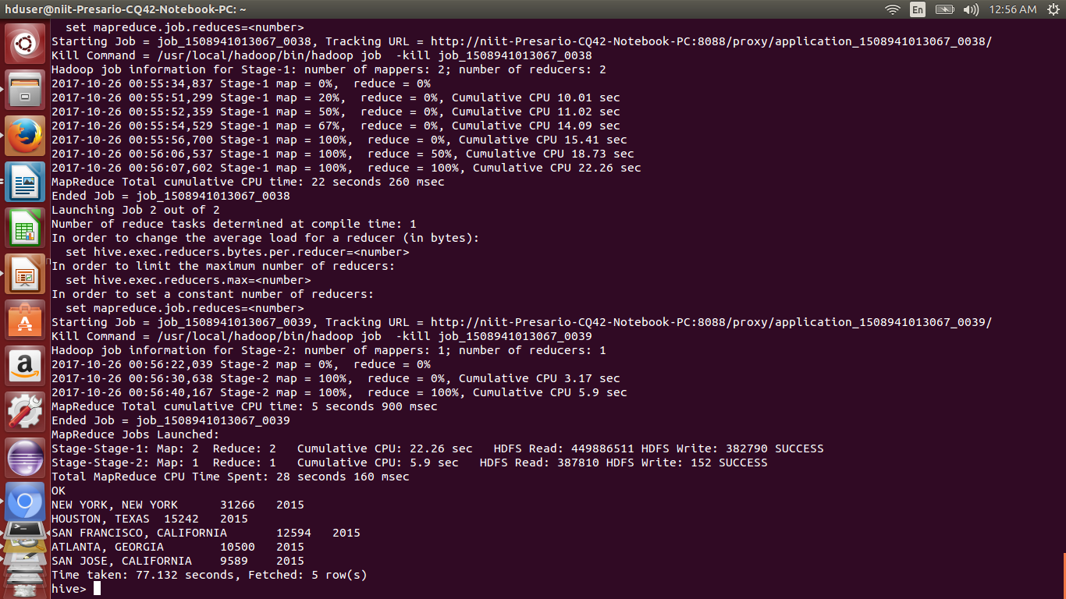
YEAR 2016
INSERT OVERWRITE LOCAL DIRECTORY '/home/hduser/Project/Hive/Question 2b/2016' row format delimited fields terminated by ',' select worksite,count(case_status) as temp,year from h1b_final where year ='2016' and case_status='CERTIFIED' group by worksite,year order by temp desc limit 5;
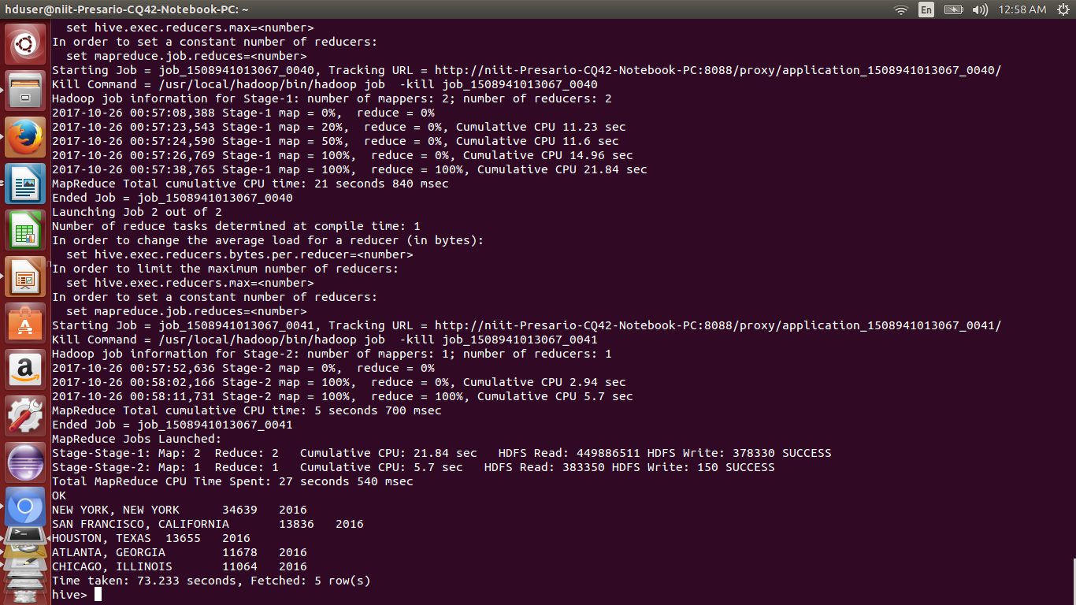

PIG:
Apache Pig is a platform for analysing large data sets that consists of a high-level language for expressing data analysis programs, coupled with infrastructure for evaluating these programs. The salient property of Pig programs is that their structure is amenable to substantial parallelization, which in turns enables them to handle very large data sets. Pig's language layer currently consists of a textual language called Pig Latin, which has the following key properties:
- Ease of programming. It is trivial to achieve parallel execution of simple, "embarrassingly parallel" data analysis tasks. Complex tasks comprised of multiple interrelated data transformations are explicitly encoded as data flow sequences, making them easy to write, understand, and maintain.
- Optimization opportunities. The way in which tasks are encoded permits the system to optimize their execution automatically, allowing the user to focus on semantics rather than efficiency.
- Extensibility. Users can create their own functions to do special-purpose processing.

7.1) TASK : 1 b) Find top 5 job titles who are having highest avg growth in applications.
Pig -x local -f question1b.pig
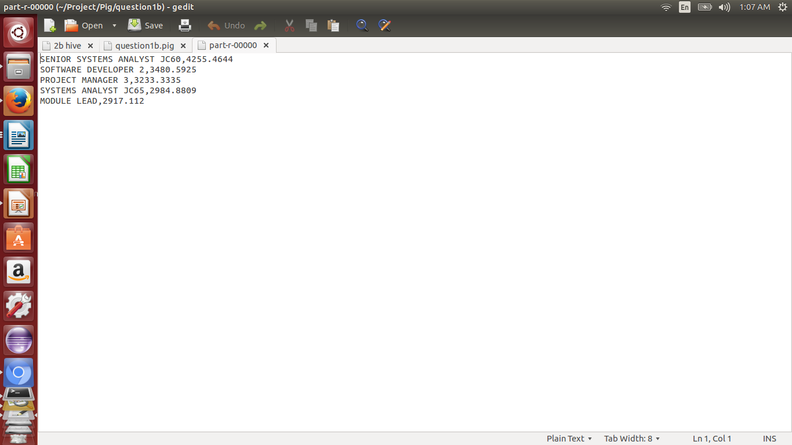
TASK 10 ):
10) Which are the job positions along with the number of petitions which have the success rate more than 70% in petitions (total petitions filed 1000 OR more than 1000)?
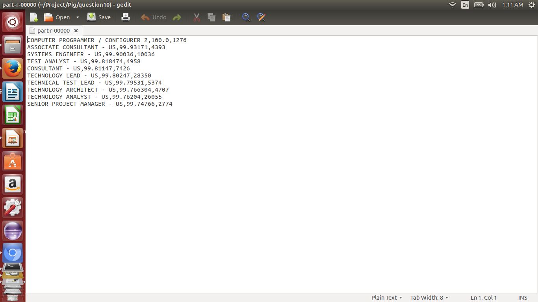

TASK 6) :
6) Find the percentage and the count of each case status on total applications for each year. Create a line graph depicting the pattern of All the cases over the period of time.

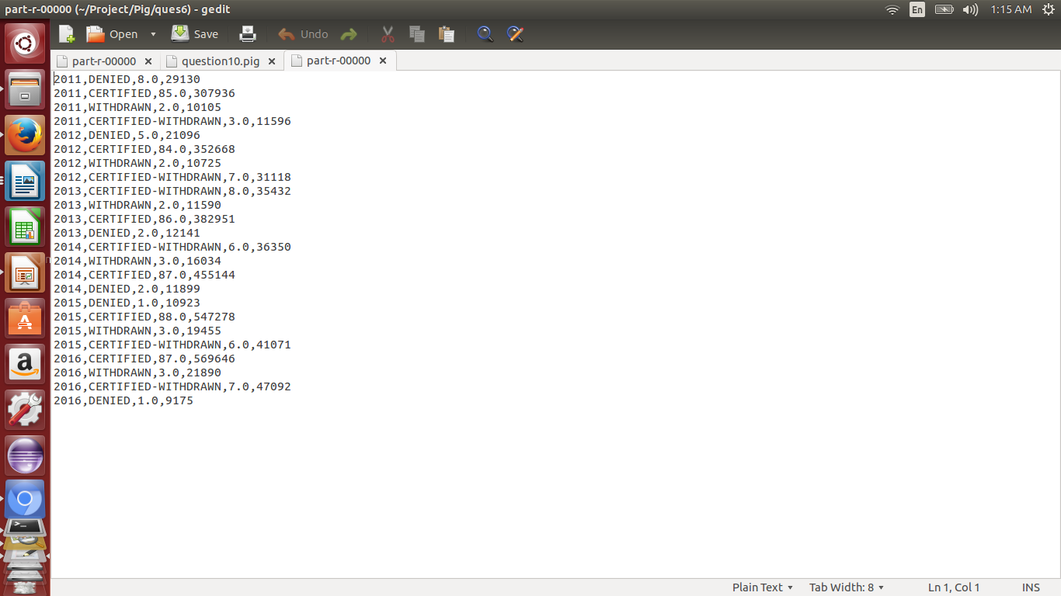
Task 9 ) Which are the employers along with the number of petitions who have the success rate more than 70% in petitions. (total petitions filed 1000 OR more than 1000) ?
pig -x local -f question9.pig
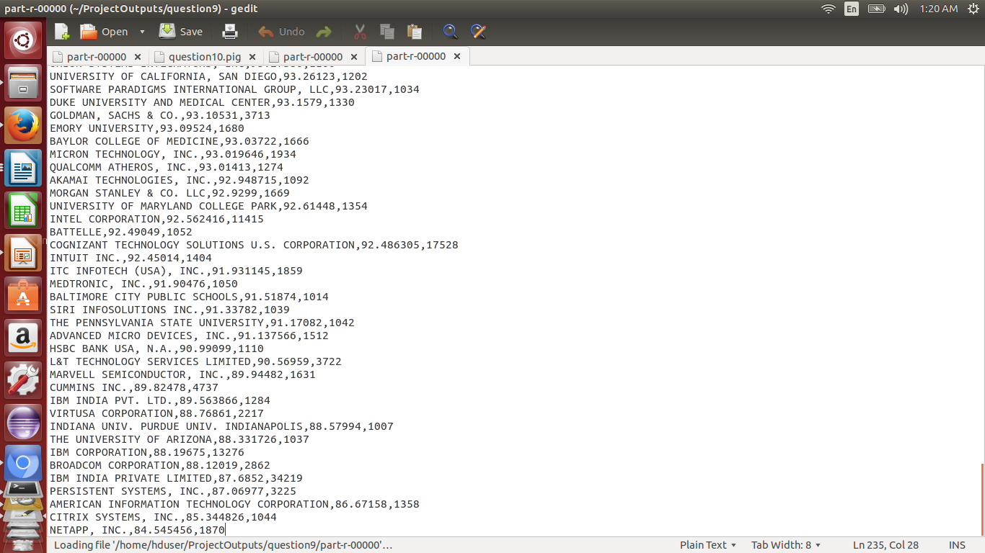
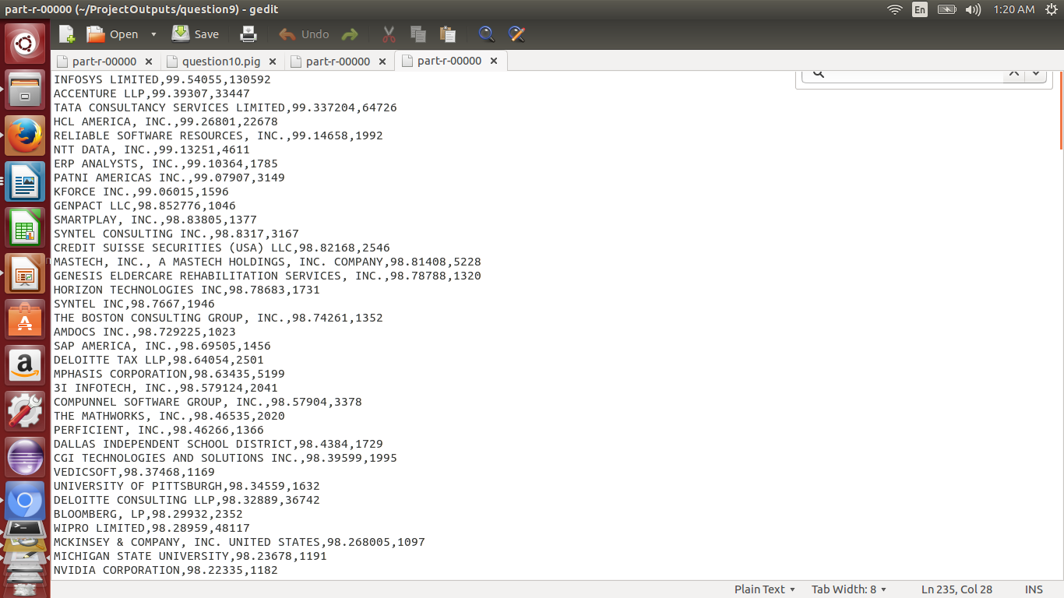
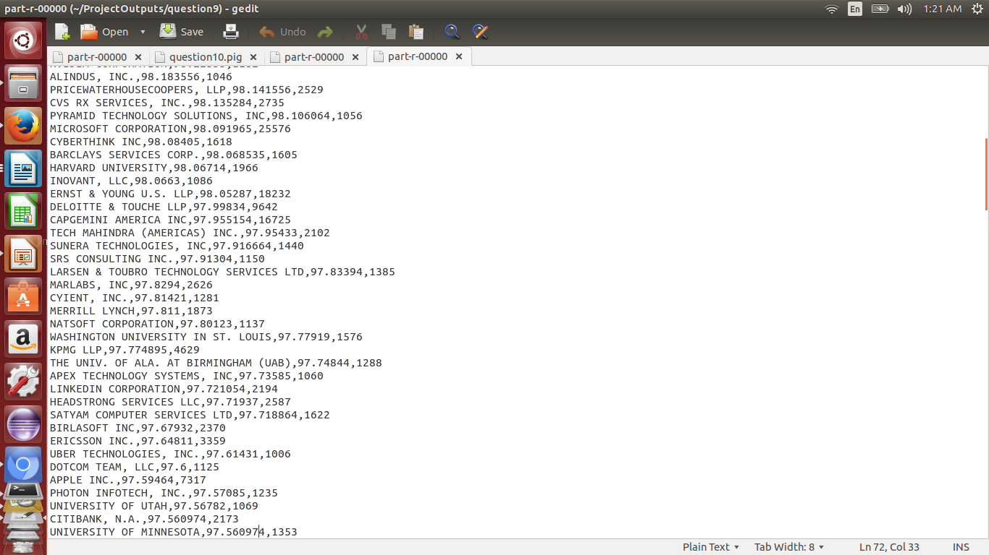
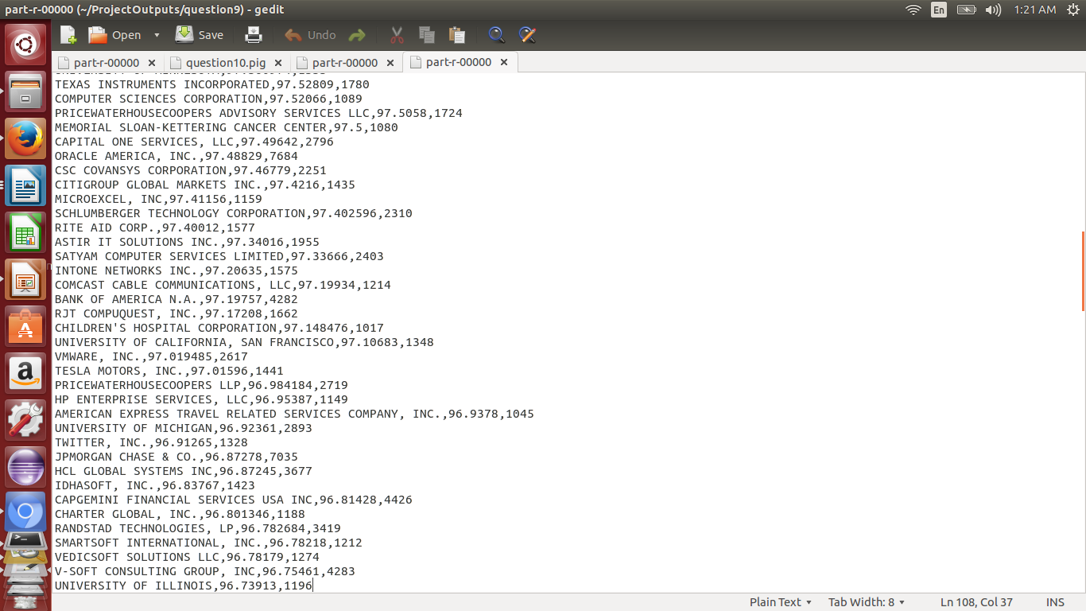

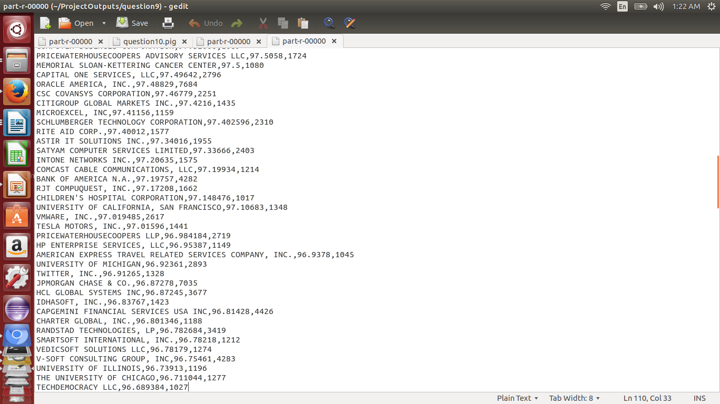

MAPREDUCE:
MapReduce is a framework designed for writing programs that process large volume of structured and unstructured data in parallel fashion across a cluster, in a reliable and fault-tolerant manner. MapReduce is all about Key-Value pair. The java.util.Map interface is used for key-value in Java.
A MapReduce program usually consists of the following 3 parts:
1. Mapper
2. Reducer
3. Driver
As the name, itself states Map and Reduce, the code is divided basically into two phases one is Map and second is Reduce. Both phase has an input and output as key-value pairs. Programmer has been given the liberty to choose the data model for the input and output for Map and Reduce both. Depending upon the business problem we need to use the appropriate data model.

8.1) What Mappers does?
- The Map function reads the input files as key/value pairs, processes each, and generates zero or more output key/value pairs.
- The Map class extends Mapper class which is a subclass of java.lang.Object:org.apache.hadoop.mapreduce.Mapper
- The input and output types of the map can be (and often are) different from each other.
- For example, if the application is doing a word count, the map function would break the line into words and output a key/value pair for each word. Each output pair would contain the word as the key and the number of instances of that word in the line as the value.
- The Map function is also a good place to filter any unwanted fields/ data from input file, we take the data only we are interested to remove unnecessary workload.

8.2) What Reducer does?
- The Reducer code reads the outputs generated by the different mappers as pairs and emits key value pairs.
- Reducer reduces a set of intermediate values which share a key to a smaller set of values.
- The Reduce class extends Reducer class which is a subclass of java.lang.Object : org.apache.hadoop.mapreduce.Reducer.
- Reducer has 3 primary phases: shuffle, sort and reduce.
- Each reduce function processes the intermediate values for a particular key generated by the map function. There exists a one-one mapping between keys and reducers.
- Multiple reducers run in parallel, as they are independent of one another. The number of reducers for a job is decided by the programmer. By default, the number of reducers is 1.
- The output of the reduce task is typically written to the FileSystem via
OutputCollector.collect(WritableComparable, Writable)
8.3) TASK question 1 a) :1 a) Is the number of petitions with Data Engineer job title increasing over time?
import org.apache.hadoop.conf.Configuration;
import org.apache.hadoop.fs.Path;
import org.apache.hadoop.io.LongWritable;
import org.apache.hadoop.io.Text;
import org.apache.hadoop.mapreduce.Job;
import org.apache.hadoop.mapreduce.lib.input.FileInputFormat;
import org.apache.hadoop.mapreduce.lib.output.FileOutputFormat;

public class Q1a {
public static void main(String args[]) throws Exception
{
Configuration conf= new Configuration();
Job job= Job.getInstance(conf,"Question 1a");
job.setJarByClass(Question1a.class);
job.setMapperClass(Question1aMapper.class);
job.setReducerClass(Question1aReducer.class);

job.setMapOutputKeyClass(Text.class);
job.setMapOutputValueClass(LongWritable.class);

job.setOutputKeyClass(Text.class);
job.setOutputValueClass(LongWritable.class);

FileInputFormat.addInputPath(job,new Path(args[0]));
FileOutputFormat.setOutputPath(job, new Path(args[1]));

System.exit(job.waitForCompletion(true)?1:0);

}
}
Mapper1a.java
import java.io.IOException;
import org.apache.hadoop.io.LongWritable;
import org.apache.hadoop.io.Text;
import org.apache.hadoop.mapreduce.Mapper;

public class Question1aMapper extends Mapper<LongWritable,Text,Text,LongWritable>{

LongWritable one =new LongWritable(1);
public void map(LongWritable key,Text values,Context context) throws IOException, InterruptedException
{
if(key.get()> 0)
{
String [] token=values.toString().split(",(?=([^\"]*\"[^\"]*\")*[^\"]*$)");
if(token[4]!=null && token[4].contains("DATA ENGINEER") && token[7]!=null && !token[7].equals("NA"))
{ Text answer= new Text("DATA ENGINEER"+","+token[7]);
context.write(answer,one);
}
}
}
}
Reducer1a.java
import java.io.IOException;
import org.apache.hadoop.io.LongWritable;
import org.apache.hadoop.io.Text;
import org.apache.hadoop.mapreduce.Reducer;

public class Question1aReducer extends Reducer <Text,LongWritable,Text,LongWritable>
{ LongWritable SUM=new LongWritable(0); int i=0;
String[] years={"2011","2012","2013","2014","2015","2016"};
long [] arr=new long[6];
public void reduce(Text key,Iterable<LongWritable> values ,Context context) throws IOException, InterruptedException
{
long sum=0;
for(LongWritable val:values)
sum+=val.get();
arr[i++]=sum;
}

public void cleanup(Context context) throws IOException, InterruptedException
{
for (int i=0;i<6;i++)
if (i==0)
context.write(new Text(years[i]), new LongWritable(0));
else
context.write(new Text(years[i]),new LongWritable((arr[i]-arr[i-1])*100/arr[i-1]));

}

}
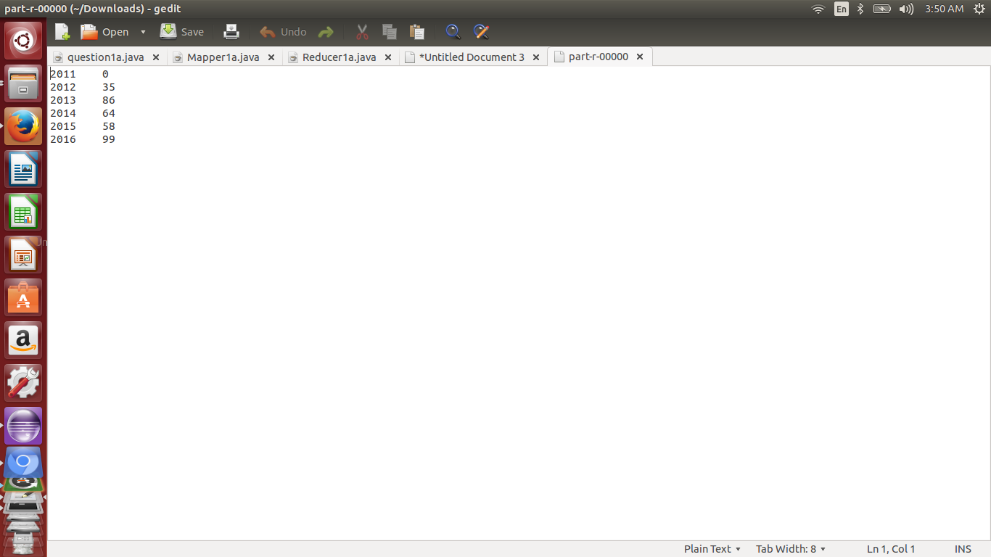
TASK 2A:2 a) Which part of the US has the most Data Engineer jobs for each year?
import java.io.IOException;
import java.util.TreeMap;

import org.apache.hadoop.io.Text;
import org.apache.hadoop.io.LongWritable;
import org.apache.hadoop.io.NullWritable;
import org.apache.hadoop.mapreduce.Job;
import org.apache.hadoop.mapreduce.Mapper;
import org.apache.hadoop.mapreduce.Partitioner;
import org.apache.hadoop.mapreduce.Reducer;
import org.apache.hadoop.conf.Configuration;
import org.apache.hadoop.fs.Path;
import org.apache.hadoop.mapreduce.lib.input.FileInputFormat;
import org.apache.hadoop.mapreduce.lib.output.FileOutputFormat;
public class Q2a
{
public static class Q2aMapper extends Mapper < LongWritable, Text, Text, LongWritable >
{
LongWritable one = new LongWritable(1);
public void map(LongWritable key, Text values, Context context) throws IOException,InterruptedException
{
if (key.get() > 0)
{
String[] token = values.toString().split("\t");
if (token[4] != null && token[4].contains("DATA ENGINEER") && token[8] != null && !token[8].equals("NA")) {
Text answer = new Text(token[8]+"\t"+token[7]);
context.write(answer, one);
}
}

}

}
public static class Q2aReducer extends Reducer<Text,LongWritable,NullWritable,Text>
{
private TreeMap<LongWritable, Text> Top5DataEngineer = new TreeMap<LongWritable, Text>();
long sum=0;
public void reduce(Text key,Iterable <LongWritable> values,Context context) throws IOException, InterruptedException
{
sum=0;
for(LongWritable val:values)
{
sum+=val.get();
}
Top5DataEngineer.put(new LongWritable(sum),new Text(key+","+sum));
if (Top5DataEngineer.size()>5)
Top5DataEngineer.remove(Top5DataEngineer.firstKey());
}
protected void cleanup(Context context)throws IOException, InterruptedException
{
for (Text t : Top5DataEngineer.descendingMap().values())
context.write(NullWritable.get(), t);
}
}
public static class Q2aPartitioner extends Partitioner < Text, LongWritable >
{
public int getPartition(Text key, LongWritable value, int numReduceTasks) {
String[] str = key.toString().split("\t");
if (str[1].equals("2011"))
{
return 0;
}
if (str[1].equals("2012"))
{
return 1;
}
if (str[1].equals("2013"))
{
return 2;
}
if (str[1].equals("2014"))
{
return 3;
}
if (str[1].equals("2015"))
{
return 4;
}
if (str[1].equals("2016"))
{
return 5;
}
else
{
return 6;
}
}
}
public static void main(String args[]) throws IOException, InterruptedException, ClassNotFoundException
{
Configuration conf = new Configuration();
Job job = Job.getInstance(conf, "Top Data Engineer in a worksite");

job.setJarByClass(Q2a.class);
job.setMapperClass(Q2aMapper.class);
job.setPartitionerClass(Q2aPartitioner.class);
job.setReducerClass(Q2aReducer.class);
job.setNumReduceTasks(7);
job.setMapOutputKeyClass(Text.class);
job.setMapOutputValueClass(LongWritable.class);
job.setOutputKeyClass(NullWritable.class);
job.setOutputValueClass(Text.class);
FileInputFormat.addInputPath(job, new Path(args[0]));
FileOutputFormat.setOutputPath(job, new Path(args[1]));
System.exit(job.waitForCompletion(true) ? 0 : 1);
}
}
FOR 2011
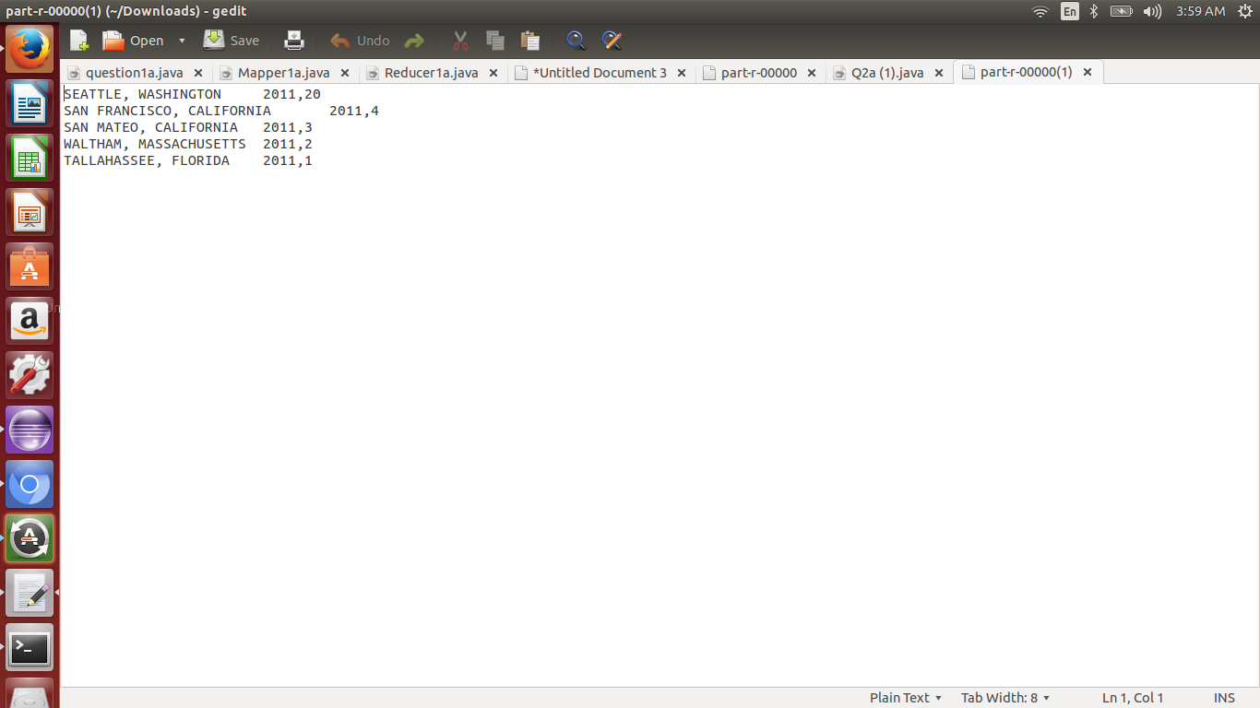
FOR 2012

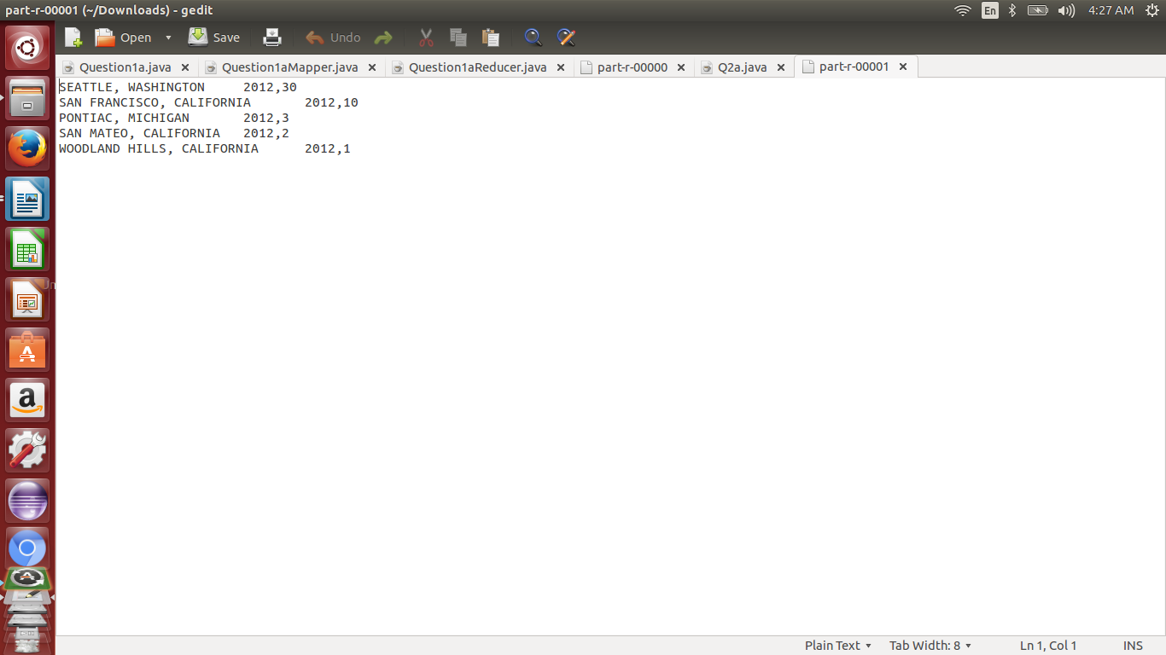
FOR 2013

FOR 2013

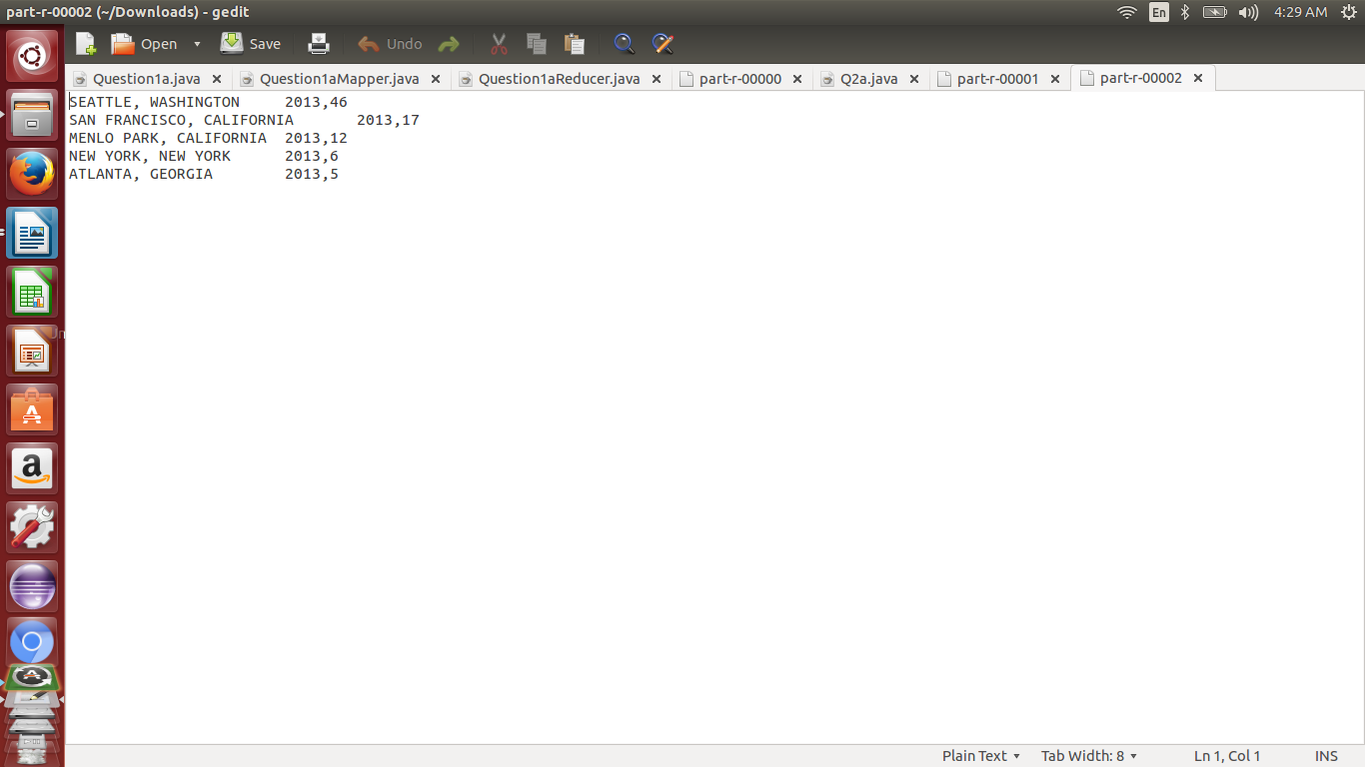
AND SO ON FOR 2014,2015,2016

TASK 3: 3)Which industry(SOC_NAME) has the most number of Data Scientist positions?
[certified]

import org.apache.hadoop.io.Text;
import org.apache.hadoop.io.LongWritable;
import org.apache.hadoop.io.NullWritable;
import org.apache.hadoop.mapreduce.Job;
import org.apache.hadoop.mapreduce.Mapper;
import org.apache.hadoop.mapreduce.Reducer;

import java.io.IOException;
import java.util.TreeMap;

import org.apache.hadoop.conf.Configuration;
import org.apache.hadoop.fs.Path;
import org.apache.hadoop.mapreduce.lib.input.FileInputFormat;
import org.apache.hadoop.mapreduce.lib.output.FileOutputFormat;
public class Q3
{
public static class Q3Mapper extends Mapper < LongWritable, Text, Text, LongWritable >
{
LongWritable one = new LongWritable(1);
public void map(LongWritable key, Text values, Context context) throws IOException,InterruptedException
{
if (key.get() > 0)
{
String[] token = values.toString().split("\t");
if (token[4].contains("DATA SCIENTIST") && token[1].equals("CERTIFIED"))
{
Text answer = new Text(token[3]);
context.write(answer, one);
}
}
}
}
public static class Q3Reducer extends Reducer < Text, LongWritable, NullWritable, Text >
{
private TreeMap < LongWritable,
Text > DataScientistJobs = new TreeMap < LongWritable,Text > ();

public void reduce(Text key, Iterable < LongWritable > values, Context context) throws IOException,InterruptedException
{

long sum = 0;
for (LongWritable val: values)
sum += val.get();

DataScientistJobs.put(new LongWritable(sum), new Text(key.toString().replaceAll("\"", "") + "," + sum));
if (DataScientistJobs.size() > 5)
{
DataScientistJobs.remove(DataScientistJobs.firstKey());
}
}

protected void cleanup(Context context) throws IOException,
InterruptedException {
for (Text t: DataScientistJobs.descendingMap().values())
{
context.write(NullWritable.get(), t);
}

}

}
public static void main(String args[]) throws Exception {
Configuration conf = new Configuration();
Job job = Job.getInstance(conf, "Data Scientist jobs");

job.setJarByClass(Q3.class);
job.setMapperClass(Q3Mapper.class);
job.setReducerClass(Q3Reducer.class);
job.setMapOutputKeyClass(Text.class);
job.setMapOutputValueClass(LongWritable.class);
job.setOutputKeyClass(NullWritable.class);
job.setOutputValueClass(Text.class);
FileInputFormat.setInputPaths(job, new Path(args[0]));
FileOutputFormat.setOutputPath(job, new Path(args[1]));
System.exit(job.waitForCompletion(true) ? 1 : 0);
}
}
OUTPUT
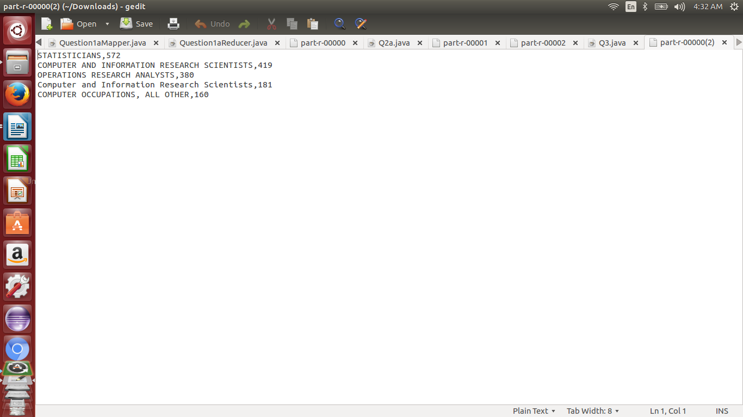

TASK4:
4)Which top 5 employers file the most petitions each year? - Case Status – ALL

import java.io.IOException;
import java.util.TreeMap;

import org.apache.hadoop.conf.Configuration;
import org.apache.hadoop.fs.Path;
import org.apache.hadoop.io.LongWritable;
import org.apache.hadoop.io.NullWritable;
import org.apache.hadoop.io.Text;
import org.apache.hadoop.mapreduce.Job;
import org.apache.hadoop.mapreduce.Mapper;
import org.apache.hadoop.mapreduce.Partitioner;
import org.apache.hadoop.mapreduce.Reducer;
import org.apache.hadoop.mapreduce.lib.input.FileInputFormat;
import org.apache.hadoop.mapreduce.lib.input.TextInputFormat;
import org.apache.hadoop.mapreduce.lib.output.FileOutputFormat;
import org.apache.hadoop.mapreduce.lib.output.TextOutputFormat;
public class Q4
{
public static class Q4Mapper extends Mapper<LongWritable,Text,Text,LongWritable>
{
LongWritable one =new LongWritable(1);
public void map(LongWritable key,Text values,Context context) throws IOException, InterruptedException,ArrayIndexOutOfBoundsException
{
try
{
if(key.get()> 0)
{
String[] token=values.toString().split("\t");
if (!token[1].equals("NA") && token[1] != null && !token[2].equals("NA") && token[2] != null && !token[7].equals("NA") && token[7] != null)
{ Text answer= new Text(token[2]+'\t'+token[7]);
context.write(answer,one);
}
}
}
catch (ArrayIndexOutOfBoundsException e)
{}
}
}
public static class Q4Reducer extends Reducer < Text, LongWritable, NullWritable, Text >
{
private TreeMap < LongWritable,Text > Top5Employers = new TreeMap < LongWritable,
Text > ();
long sum = 0;
public void reduce(Text key, Iterable < LongWritable > values, Context context) throws IOException,
InterruptedException {
sum = 0;
for (LongWritable val: values) {
sum += val.get();
}
Top5Employers.put(new LongWritable(sum), new Text(key + "," + sum));
if (Top5Employers.size() > 5)
Top5Employers.remove(Top5Employers.firstKey());

}
protected void cleanup(Context context) throws IOException,
InterruptedException {
for (Text t: Top5Employers.descendingMap().values())
context.write(NullWritable.get(), t);

}
}
public static class Q4Partitioner extends Partitioner < Text, LongWritable >
{
public int getPartition(Text key, LongWritable value, int numReduceTasks)
{
String[] str = key.toString().split("\t");
if (str[1].equals("2011"))
{
return 0;
}
else if (str[1].equals("2012"))
{
return 1;
}
else if (str[1].equals("2013"))
{
return 2;
}
else if (str[1].equals("2014"))
{
return 3;
}
else if (str[1].equals("2015"))
{
return 4;
}
else if (str[1].equals("2016"))
{
return 5;
}
else
{
return 6;
}
}
}
public static void main(String args[]) throws Exception
{
Configuration conf= new Configuration();
Job job= Job.getInstance(conf,"Question 4");
job.setJarByClass(Q4.class);
FileInputFormat.setInputPaths(job,new Path(args[0]));
FileOutputFormat.setOutputPath(job, new Path(args[1]));
job.setMapperClass(Q4Mapper.class);
job.setPartitionerClass(Q4Partitioner.class);
job.setReducerClass(Q4Reducer.class);
job.setNumReduceTasks(7);
job.setInputFormatClass(TextInputFormat.class);
job.setOutputFormatClass(TextOutputFormat.class);
job.setMapOutputKeyClass(Text.class);
job.setMapOutputValueClass(LongWritable.class);
job.setOutputKeyClass(NullWritable.class);
job.setOutputValueClass(Text.class);
System.exit(job.waitForCompletion(true)?1:0);
}
}
OUTPUT

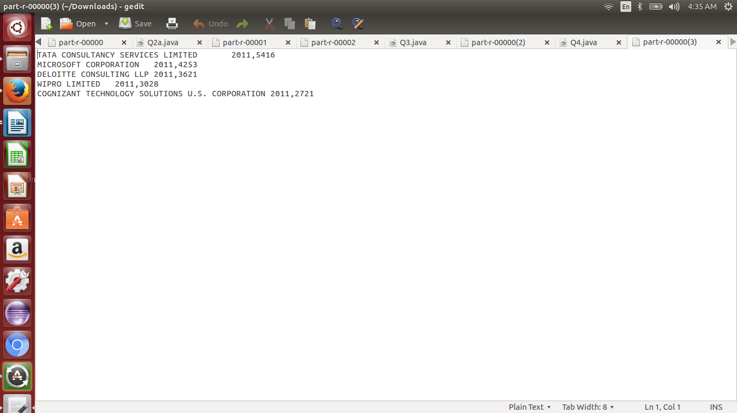
AND SO ON FOR REST

CONCLUSIONS:

Following is the conclusion that we can draw based on the tasks performed by us:
- dont open the hib.csv in excel data may corrupt.
- For group by, join and filter based data retrieval Pig is very efficient.
- MapReduce code written in Java makes the complex analysis quite easy.
- From the census data and after running all the tasks we can conclude that
- This project provides the of population summary of hib visa applications. The total applications is 3,00,000.
- Though MapReduce code written in Java makes the complex analysis quite easy, Hive and Pig are easier to retrieve data efficiently and lines of code is also very less compared to MapReduce programs.

REFERENCES:
http://thornydev.blogspot.in/2013/07/querying-json-records-via-hive.html
http://hadoop.apache.org/
https://hadoop.apache.org/docs/r1.2.1/mapred_tutorial.html
http://hortonworks.com/hadoop-tutorial/how-to-use-basic-pig-commands/
http://hortonworks.com/hadoop-tutorial/how-to-process-data-with-apache-hive/
https://www.sas.com/en_us/insights/big-data/hadoop.html

ACKNOWLEDGEMENT:

I would like to thank NIIT from whom I have learned and will continue to learn. In particular, I would like to thank Mr. Annu Sharma sir and Mr. Sandeep Agarwal sir for their support and for providing so many case studies. I would also thank my tech mentor Mr. Shakun Tyagi for timely support and providing helpful suggestion.

